
Audio Typing Form
(lastmodified=06/09/24)
Group no / tribe:
Choose an item.

A. |  | Announcements sheet ❎ and MP3 |  |  | Sermon Date:  Service Date  Holy Day Type:
B. |  | Today’s Date: |  | 00/00/0000 | Your name:  Other typists:
C. |  | Preacher: |  |  | Type of sermon:
D |  | Location:
Notes:
E. | Mini sermon title:
 | Write Book, Chapter and Verse  Or Preacher |  | Quote: |  |  |  |  | For Verifier
[INSERT SERMON TITLE HERE]
F. | Main Sermon title:
 | Write Book, Chapter and Verse  Or Preacher |  | Quote: |  |  |  | For Verifier

Symbols to use in the second column
&
“Yahshua answered, The first is, Hear, O Israel...”
Mark 12:29
Sacred Scriptures Bethel Edition

Reflect:
Feel free to reflect on how the audio typing has gone. Feel free to add any problems you had or have, perhaps with the spelling of words or the making out of certain words. This might be able to be rectified by someone else.

[For Admin Only] ----------------------------------------------------------------------------

Verifier to print name or sign:: Date:
dd/mm/yyyy

Group no / tribe: Duration of sermon(s) :
0:00:00 (MINI)
0:00:00 (MAIN)

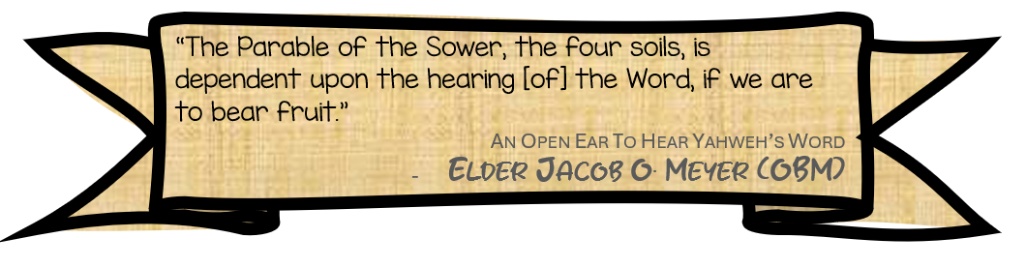
Mini report:
Please briefly conclude how the verification went.

www.messianicisraelite.com
“Open the door”
Hoped to be part of the:


DISCLAIMER: This site has not yet been endorsed by the Assemblies of Yahweh and is not a part of the Living Ways Youth Program. The editor has built this site to be part of the Living Way Youth Program, a program of the Assemblies of Yahweh (Bethel, PA)

