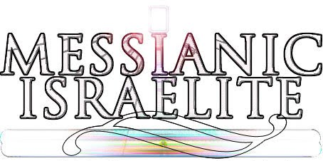
Challenge Creation: ♘
(lastmodified=18/02/23)
(lastmodified=18/04/23)

About this form:
This is the Create a challenge form. It’s where you compile your challenge questions and answers to send to the Living Way. You should read the instructional form before you attempt to fill out this form.

Print name: Date:
dd/mm/yyyy

Group no / tribe:
Choose an item.

What to do:
They are 7 challenge question tables and their corresponding 7 challenge answer tables. Fill them out according to how the instruction form states and send this form to the living way email address. Please do not delete the tick and cross symbols above each table. You may want to copy them to include in the answer part of your challenges. Thank you.

The 7 challenge question table part
Below are the 7 challenge question tables. These are the challenges which the recipient of the challenges will have to work out. Fill in the tables below.

:
Question Part No.1
❎Challenge #

Question Part No.2
❎Challenge #

Question Part No.3
❎Challenge #

Question Part No.4
❎Challenge #

Question Part No.5
❎Challenge #

Question Part No.6
❎Challenge #

Question Part No.7
❎Challenge #

The 7 challenge answers table part
Below are the 7 challenge answer tables. These are the challenges answers which the recipient of the challenges will be able to use to work out if they were successful with their answers or not and be able to calculate how many points they scored for each challenge. They should correspond to the challenge question tables.

Answer Part No.1
❎Challenge answer #

Answer Part No.2
❎Challenge answer #

Answer Part No.3
❎Challenge answer #

Answer Part No.4
❎Challenge answer #

Answer Part No.5
❎Challenge answer #

Answer Part No.6
❎Challenge answer #

Answer Part No.7
❎Challenge answer #

Template:
A.B Food for thought quiz

Spirituality room:
If you are doing volunteering in your tribe, you can obtain points for your tribe by having the spirituality points added to the scoresheet.
The study corner (1) | The chat corner*  (0) | The witnessing corner (0) | The media corner  (1)
*You can receive a chat spiritual point by doing H challenges
Advice: 🖊
This form is to be used to create your challenges. You are to save it once done and send to the Living Way if you are a contributor, or your tribe leader if you are a volunteer. Need any help? There’s an Instructions form on www.messianicisraelite.com
Thanks in Advance!

“...and let us consider one another to provoke to love and good works.”
Hebrews 10:24
Sacred Scriptures Bethel Edition

“May Yahweh challenge us daily to do His Will...”
The Seven Lamps of Yahweh
Elder Jacob O. Meyer

www.messianicisraelite.com
“Open the door”

Hoped to be part of the:
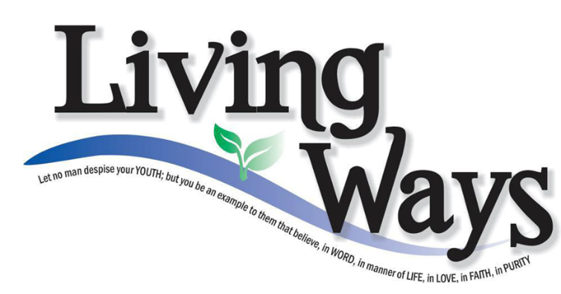

DISCLAIMER: This site has not yet been endorsed by the Assemblies of Yahweh and is not a part of the Living Ways Youth Program. The editor has built this site to be part of the Living Way Youth Program, a program of the Assemblies of Yahweh (Bethel, PA)

