Online Witnessing:
(lastmodified=15//02/23)
(lastmodified=18//02/23)

About this form:
Please fill out this form if you have done some shield  online witnessing.

Print name or sign:: Date:

dd/mm/yyyy

Group no / tribe:
Choose an item.

Forum:
Please insert the forum link in the row in this table below
www.

Threads:
Please insert the post or thread links you have contributed to in the row in this table below (insert more rows if needed)
www.
www.
www.
www.
www.

Time splitter:
Please split the time you have spent in the forum accordingly
Total time =
Browsing time =
Writing posts =
Other =

Mini report:
Please give us a mini report of how your witnessing went today.

Satisfaction Grade:
Rate how it went. ( A is the highest grade, E is the lowest grade ) Tick checkbox next to the correct letter.
Ⓐ☐ | Ⓑ☐ | Ⓒ☐ | Ⓓ☐ | Ⓔ☐

Spirituality room:
If you are doing volunteering in your tribe, you can obtain points for your tribe by having the spirituality points added to the scoresheet.
The study corner (0.5) | The chat corner  (1) | The witnessing corner (1) | The media corner  (0)

Advice: 🖊
Once you have filled out this form, remember there is a specific way to save the form. Go to the instructions form to find out how to save this document before you send it as an attachment in email to the Living Way if you are a contributor or your tribe leader if you are a volunteer.

Need any help? Check out the instructions form.

“and with all taking up the shield of faith, with which you shall be able to quench the fiery darts of the evil one.”
Ephesians 6:16
Sacred Scriptures Bethel Edition

“...I showed that the 144,000, each one of them individually, can serve as a witness”
Yahweh and His Witnesses
Elder Jacob O. Meyer

www.messianicisraelite.com
“Open the door”

Hoped to be part of the:
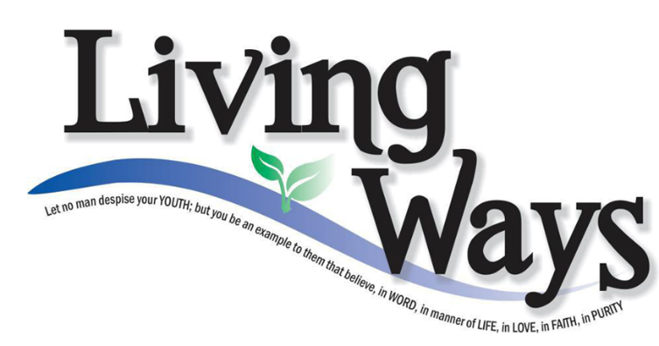

DISCLAIMER: This site has not yet been endorsed by the Assemblies of Yahweh and is not a part of the Living Ways Youth Program. The editor has built this site to be part of the Living Way Youth Program, a program of the Assemblies of Yahweh (Bethel, PA)

