Music Makers: ♫
(lastmodified=18/02/23)
(lastmodified=27//02/23)

About this form:
Please fill this form out if you have created spiritual music. Please note this should only be contributed to by those affiliated with the Assemblies of Yahweh.

Print name or sign:: Date:

dd/mm/yyyy

Group no / tribe: Age
Choose an item.

Song type and details:
Song type | Details (write below)
☐ From AOY songbook  ☐ From another source  ☐ Song created from scratch | i.e. such as page number and song title.

Song Lyrics:
Type below the song lyrics:

Record and Insert song below:
Instructions: If you wish to have your song published on Living Way Facebook page, skip this box and go on to the next one.
See the instructions form to find how to record a song. You may go to start > all programs > accessories > sound recorder. Record and save it, then insert it in the row below. You’ll need a mic to record your songs. However, probably the most popular way will be recording the music on to your phone using an voice/song recorder app, then transferring it to the computer and inserting the file. New! You may also attach the file in the email you send with this form. If you do so, write ‘see attachment’ just below.

Link to music:
If you skipped the above box : - to show that you have created music, please upload a recording of your song to a file sharing site like OneDrive, Dropbox, Soundcloud, Soundtrap, Youtube etc. and share the private link with us. Please insert the link below:
www.

Name(s) and instruments:
Write the names of the people in the song and their age. Write ‘vocal’ for those who sing. Please also include ‘bass’ or ‘melody’ etc to help us grade each part. You may add more rows if you like.
Name and age: |  | Instruments:
Name and age: |  | Instruments:
Name and age: |  | Instruments:
Name and age: |  | Instruments:
Name and age: |  | Instruments:

Review:
Do you wish to have your song rated? (Tick checkbox)
Yes ☐ | No ☐

Lyric video:
Only available if you have created a song with your own words and if you have chosen to get it rated and that rating is from 3 ½ – 5 stars and if you choose to have your song shared:
Do you wish for one of our volunteers to create you a lyric video for your song (Tick checkbox)
SEE INSTRUCTIONS FORM FOR DETAILS
Yes ☐ | No ☐

Mini report:
Please briefly conclude how you found coming up with this song.

Satisfaction Grade:
Rate how it went. ( A is the highest grade, E is the lowest grade ) Tick checkbox next to the correct letter.
Ⓐ ☐ | Ⓑ☐ | Ⓒ☐ | Ⓓ☐ | Ⓔ☐

Sharing the song:
Do you give the Living Way the permission to share this song i.e. on the Living Way Facebook page or with the online group (tribe).
Note: We may only share the best of our music making contributions and even if you select yes the Living Way may choose not to share it. It may also depend on your age as the AOY would like to encourage especially the youth to make music to Yahweh.
Yes ☐ | No ☐

Spirituality room:
If you are doing volunteering in your tribe, you can obtain points for your tribe by having the spirituality points added to the scoresheet.
The study corner  (0) | The chat corner  (0) | The witnessing corner (0.5) | The media corner  (1)

Advice: 🖊
Once you have filled out this form, please send it by email to the Living Way if you are a contributor and send it to your tribe leader if you are a volunteer. Need any help? Check out the instructions form.
Thanks in advance!

“Now you have consecrated yourselves to Yahweh; come near and bring sacrifices and thank-offerings in to the house of Yahweh.”
2 Chronicles 29:31
Sacred Scriptures Bethel Edition

“Yahweh wants a perfect sacrifice…not only is the animal supposed to be a perfect sacrifice, but the music that accompanied the sacrifice also was to be perfect”
Making Good Use Of Our Talents
Elder Jacob O. Meyer

www.messianicisraelite.com
“Open the door”

Hoped to be part of the:
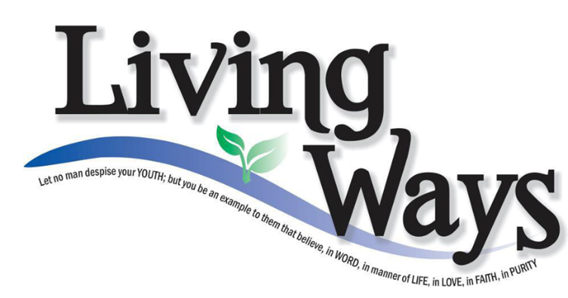

DISCLAIMER: This site has not yet been endorsed by the Assemblies of Yahweh and is not a part of the Living Ways Youth Program. The editor has built this site to be part of the Living Way Youth Program, a program of the Assemblies of Yahweh (Bethel, PA)

