Online Witnessing:
(lastmodified=15/02/23)
(lastmodified=18/02/23)

About this form:
Please fill out this form if you have done evangel  online witnessing. Remember, only fill this form out if you have been on the forum evangelizing for at least 3 days.

Print name or sign:: Date:

dd/mm/yyyy

Group no / tribe:
Choose an item.

Forum:
Please insert the forum link you’ve worked as an evangelizer on in the row in this table below
www.

Age suitability rating:
Tick the correct age rating checkbox. If you are unsure of what rating to give a forum, you can leave up to two ratings below.
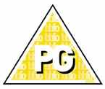 | 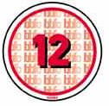 |  | 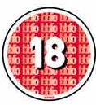 | 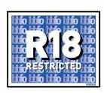
☐ | ☐ | ☐ | ☐ | ☐

Difficulty rating:
How difficult is it, or will it be, for online witnesses to shield this forum
Easy ☐ | Medium ☐ | Hard ☐ | Difficult ☐ | Impossible ☐

Time splitter:
Please estimate the time you have spent in the forum accordingly
Total days spent on forum =
Total minutes spent on forum =

Mini report:
Please give us a condensed report of the forum itself and its suitability for shields. Feel free to use links to threads.

User Name:
Write your username in the below row.
UserName=

Spirituality room:
If you are doing volunteering in your tribe, you can obtain points for your tribe by having the spirituality points added to the scoresheet.
The study corner  (0.5) | The chat corner  (1) | The witnessing corner (1) | The media corner  (0)

Advice: 🖊
Once you have filled out this form, remember there is a specific way to save the form. Go to the instructions form to find out how to save this document before you send it as an attachment in email to the Living Way if you are contributor or your tribe leader if you are a volunteer.

Need any help? Check out the instructions form.
Thanks in advance!

“But you be sober in all things, suffer hardship, do the work of the evangelist, fulfil your ministry.”
2 Timothy 4:5
Sacred Scriptures Bethel Edition

“...I showed that the 144,000, each one of them individually, can serve as a witness”
Yahweh and His Witnesses
Elder Jacob O. Meyer

www.messianicisraelite.com
“Open the door”

Hoped to be part of the:
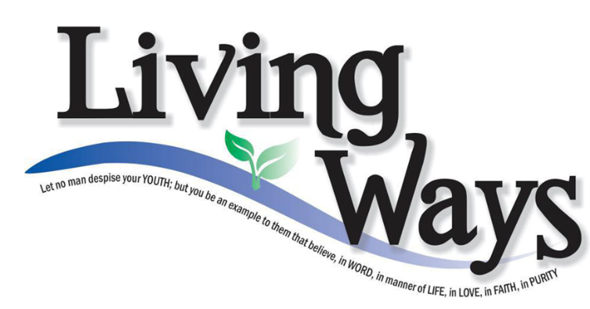

DISCLAIMER: This site has not yet been endorsed by the Assemblies of Yahweh and is not a part of the Living Ways Youth Program. The editor has built this site to be part of the Living Way Youth Program, a program of the Assemblies of Yahweh (Bethel, PA)

