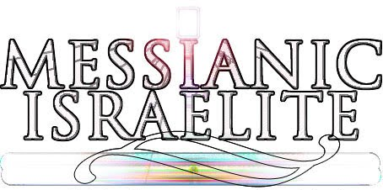
Online Witnessing:
(lastmodified=15/02/23)
(lastmodified=18/02/23)

About this form:
Please fill out this form if you have done online editing on one of the four AOY articles on Wikipedia: Assemblies of Yahweh, Sacred Scriptures Bethel Edition, WMLK or Elder Jacob O. Meyer.

Print name or sign:: Date:

dd/mm/yyyy

Group no / tribe:
Choose an item.

Checklist:
Please paste your Wikipedia name below: i.e. In Citer (talk | contribs)
Note: the ‘hyperlinked volunteer name’ must be linked to your contribution page.
Please put the links to your edits below:
(Add more rows if necessary)
1.
2.
3.
4.
5.
6.
7.
8.
9.

Articles edited:
List the names of the articles you have edited below separating each article with a semi colon.
;

Mini report:
Please briefly conclude the edifying efforts of yourself.

Satisfaction Grade:
Rate how it went. ( A is the highest grade, E is the lowest grade ) Tick checkbox next to the correct letter.
Ⓐ☐ | Ⓑ☐ | Ⓒ☐ | Ⓓ☐ | Ⓔ☐

Spirituality corner:
If you are doing volunteering in your tribe, you can obtain points for your tribe by having the spirituality points added to the scoresheet.
The study corner  (0.5) | The chat corner  (0) | The witnessing corner (1) | The media corner  (0)

Advice: 🖊
Once you have filled out this form, please send it by email to the Living Way if you are a contributor and send it to your tribe leader if you are a volunteer. Need any help? Check out the instructions form.
Thanks in advance!

“Let no corrupt thing proceed out of your mouth, but such as is good for edifying as the need may be, that it may give grace to them that hear.”
Ephesians 4:29
Sacred Scriptures Bethel Edition

“...I showed that the 144,000, each one of them individually, can serve as a witness”
Yahweh and His Witnesses
Elder Jacob O. Meyer

www.messianicisraelite.com
“Open the door”

Hoped to be part of the:
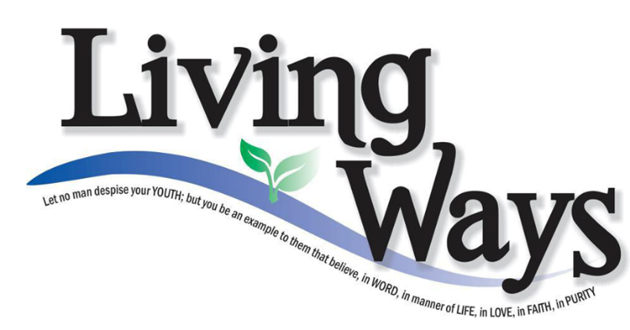

DISCLAIMER: This site has not yet been endorsed by the Assemblies of Yahweh and is not a part of the Living Ways Youth Program. The editor has built this site to be part of the Living Way Youth Program, a program of the Assemblies of Yahweh (Bethel, PA)

